Please find an overview of the 2019 Leyshon Park 6aside Competition

The 2019 competition will be managed and delivered by the El Salvador Soccer Club (ESSC) supported by Welcome Sports. This is an exciting collaboration that has been set up to add value and attract new teams and faces to the competition.

Below is a summary of the key information for players and managers.

- Change of competition coordinator.

Carlos Meza, ESSC Committee Member and Welcome Sports Director will be the main contact for teams and registration information. Carlos will be responsible for communicating details on the fixtures to players and managers and will oversee the competition on Friday nights.

- Reduction in fees from last year

The collective costs to participate in the 2019 Leyshon Park competition have been reduced for 2019. We are happy to be communicating this to you.

Here is what teams payed in 2018…

- Team Fee - $750
- Referee Fees - $250 (each week teams payed $25 cash for referees x 10 weeks of competition = $250)

2018 Collective Team Fee = $1000 per team

Here is what teams will pay in 2019…

2019 Collective Team Fee = $890 per team
This is an all inclusive fee that will be made to Welcome Sports. This will include referee payments for the year (so you don’t have to bring $25 per game each week!).

This is a $110 reduction in collective team fees from 2018!

Plus we are including:
- Player insurance
- Improved fields and surface quality
- Increasing competition management

This is what value looks like! Reducing costs and improving the participation experience.

Registering a team and securing your spot

- Team managers registered for the 2019 competition @ www.welcomesports.com.au – click ‘register a team’ on the home page or through this link – https://forms.office.com/Pages/ResponsePage.aspx?id=8ilD88eqt0aHPmbyUAk1DdFcHKHmD4RPh3Z1LXzqN2BUMEs5QVlWMklCUzVST0VTMDkwMU1LTUVYVi4u
- Once you have registered your team – Welcome Sports will send you an invoice of $250. This secures your spot in the competition.
- When the competition starts – Welcome Sports will send your team an invoice of $640. This is the remainder of the 2019 Collective Team Fee ($890)

t

- Scheduling, fixtures and divisions

Summary of competition start and finishing dates

Start date – Friday 11 October
Finishing date regular – Friday 13 December
Finishing date finals – Sunday 15th December

Game times
- 1st games - 7.00pm
- 2nd games – 7.50pm
- 3rd games – 8.40pm

(Competition managers will ensure all teams receive a combination of start times throughout the competition)

Divisions
- Men’s Division 1
- Men’s Division 2
- Women’s Open
(Competition managers will grade teams in the men’s divisions over the first 2 weeks to create an equal and balanced competition)

- Affiliation to Football QLD

The decision to affiliate the Leyshon Park 6-a-side competition was made to increase the benefits to the players participating in the competition.
Insurance cover for players via Football QLD’s insurance scheme
(Players must register online to access)
Details on insurance – click here
Support with competition management systems, processes and advise to manage competitions and support members
Opportunities to co – deliver programs and events at El Salvador and Welcome Sports to attract funding for improved facilities
Communications strategies to grow participation and reach new players in the future

- Online Registrations
The 2019 Leyshon Park 6-a-side Competition and ongoing Welcome Sports supported football programs will now include an online registration process for players. This process is via the Football Federation of Australia’s (FFA), ‘My Football’ data base and process.
We appreciate that this is a new process for many participants.
This process is in place for the following reasons:
- Ensures all players are insured before taking the field
- Protects players and administrators by acknowledging competition rules and player conduct information
- Allows ESSC & Welcome Sports to effectively demonstrate participation data to key funding bodies to support applications for program and facility improvements.
- A ‘How to Register Guide’ will be created shortly and provided to team managers – please pass this on to players in your team

Please ensure that all players are registered prior to taking the field.

- Adoption of new policies and procedures

Football QLD
Under affiliation to Football QLD, Welcome Sports members and administrators will now be protected through the following national and state policies and procedures. These are primarily connected to member protection policies and are updated regularly in line with state based legislation.

CLICK HERE to view Football QLD Policies and Procedures

El Salvador Soccer Club
Existing ESSC Leyshon Park 6aside competition rules and regulations will be in place for the 2019 competition.

Welcome Sports
The ‘Welcome Way’ is a simple list of behaviours and values that have been created across all programs and sport and recreation activities supported by Welcome Sports.

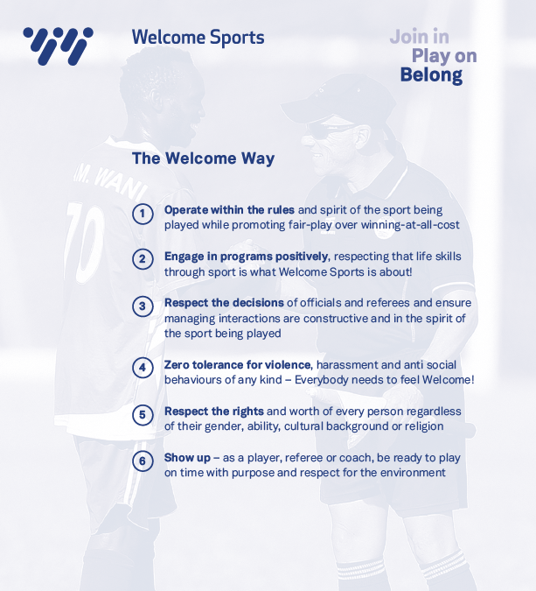

Welcome Sports Image Consent

Image consent has been added to the online registrations process. It allows us to create marketing and promotional material to support great programs moving forward. Please contact Manager of Welcome Sports, Miles Wilson if you do not want your image being used.

- Get in contact
To discuss any of the above or for any other information required, please feel free to contact:

Carlos Meza
Leyshon Park 6aside Competition Manager
Mobile: 0402 408 227
leyshonpark6aside@gmail.com

Miles Wilson
Manager of Welcome Sports
Mobile: 0432 529 833
MilesW@mdaltd.org.au

